**Landing, Login, and Enrollment Pages Development**

Theresa Musselman

The University of Arizona Global Campus

CST499: Capstone for Computer Software Technology (CSF2501A)

Professor Joseph Rangitsch

April 7, 2025

**Landing, Login, and Enrollment Pages Development**

Building upon a prior project from CST310, this assignment focuses on implementing a dynamic website by leveraging established development efforts as a foundation. Code reusability is a key principle guiding this project, emphasizing the value of reusing existing code, utilizing familiar code libraries, and adopting proven design patterns to enhance efficiency and consistency. By incorporating validated solutions, developers save valuable time and maintain uniformity across projects (Tsui et al., 2018). This paper will outline the process of creating a dynamic website with XAMPP, developing key pages like the landing, login, and registration pages, and implementing MySQL database functionalities, culminating in a comprehensive discussion of the steps taken to achieve these objectives.

When developing a student portal that allows students to view and enroll in class, the developer will use [XAMPP](https://www.apachefriends.org/index.html). First, start by downloading and installing XAMPP. Once installed, open its control panel with administrator privileges. Activate both the Apache and MySQL servers, ensuring the ports are available and the servers function correctly by visiting http://localhost/ in your browser. Next, choose an HTML5 development tool, such as WYSIWYG editors, code editors, IDEs, cloud-based platforms, or code playgrounds (Connolly & Hoar, 2022). Create a new PHP file using your selected tool (beginning with the landing page, typically named 'index.php,' as this helps the web server identify it as the main entry point). Design the webpage script within this file, utilizing [Bootstrap](https://getbootstrap.com/) for the front-end framework. Bootstrap's Content Delivery Network (CDN) can be integrated by adding the required links into the <head> section of the PHP file. After completing the PHP file, save it in the htdocs folder located within the XAMPP directory. By default, this folder is included in XAMPP and is usually found at C:\xampp\htdocs on Windows. Then, open a browser and enter the file's address in the format htto://localhost/yourfile.php (e.g., http://localhost/index.php if the file is named index.php). Press enter, and the webpage will load, displaying the PHP content styled with Bootstrap. Figure 1 shows the landing page, <http://localhost/index.php>, for the Infinite Academy education portal management system.

**Figure 1**

*Index.php Landing Page*

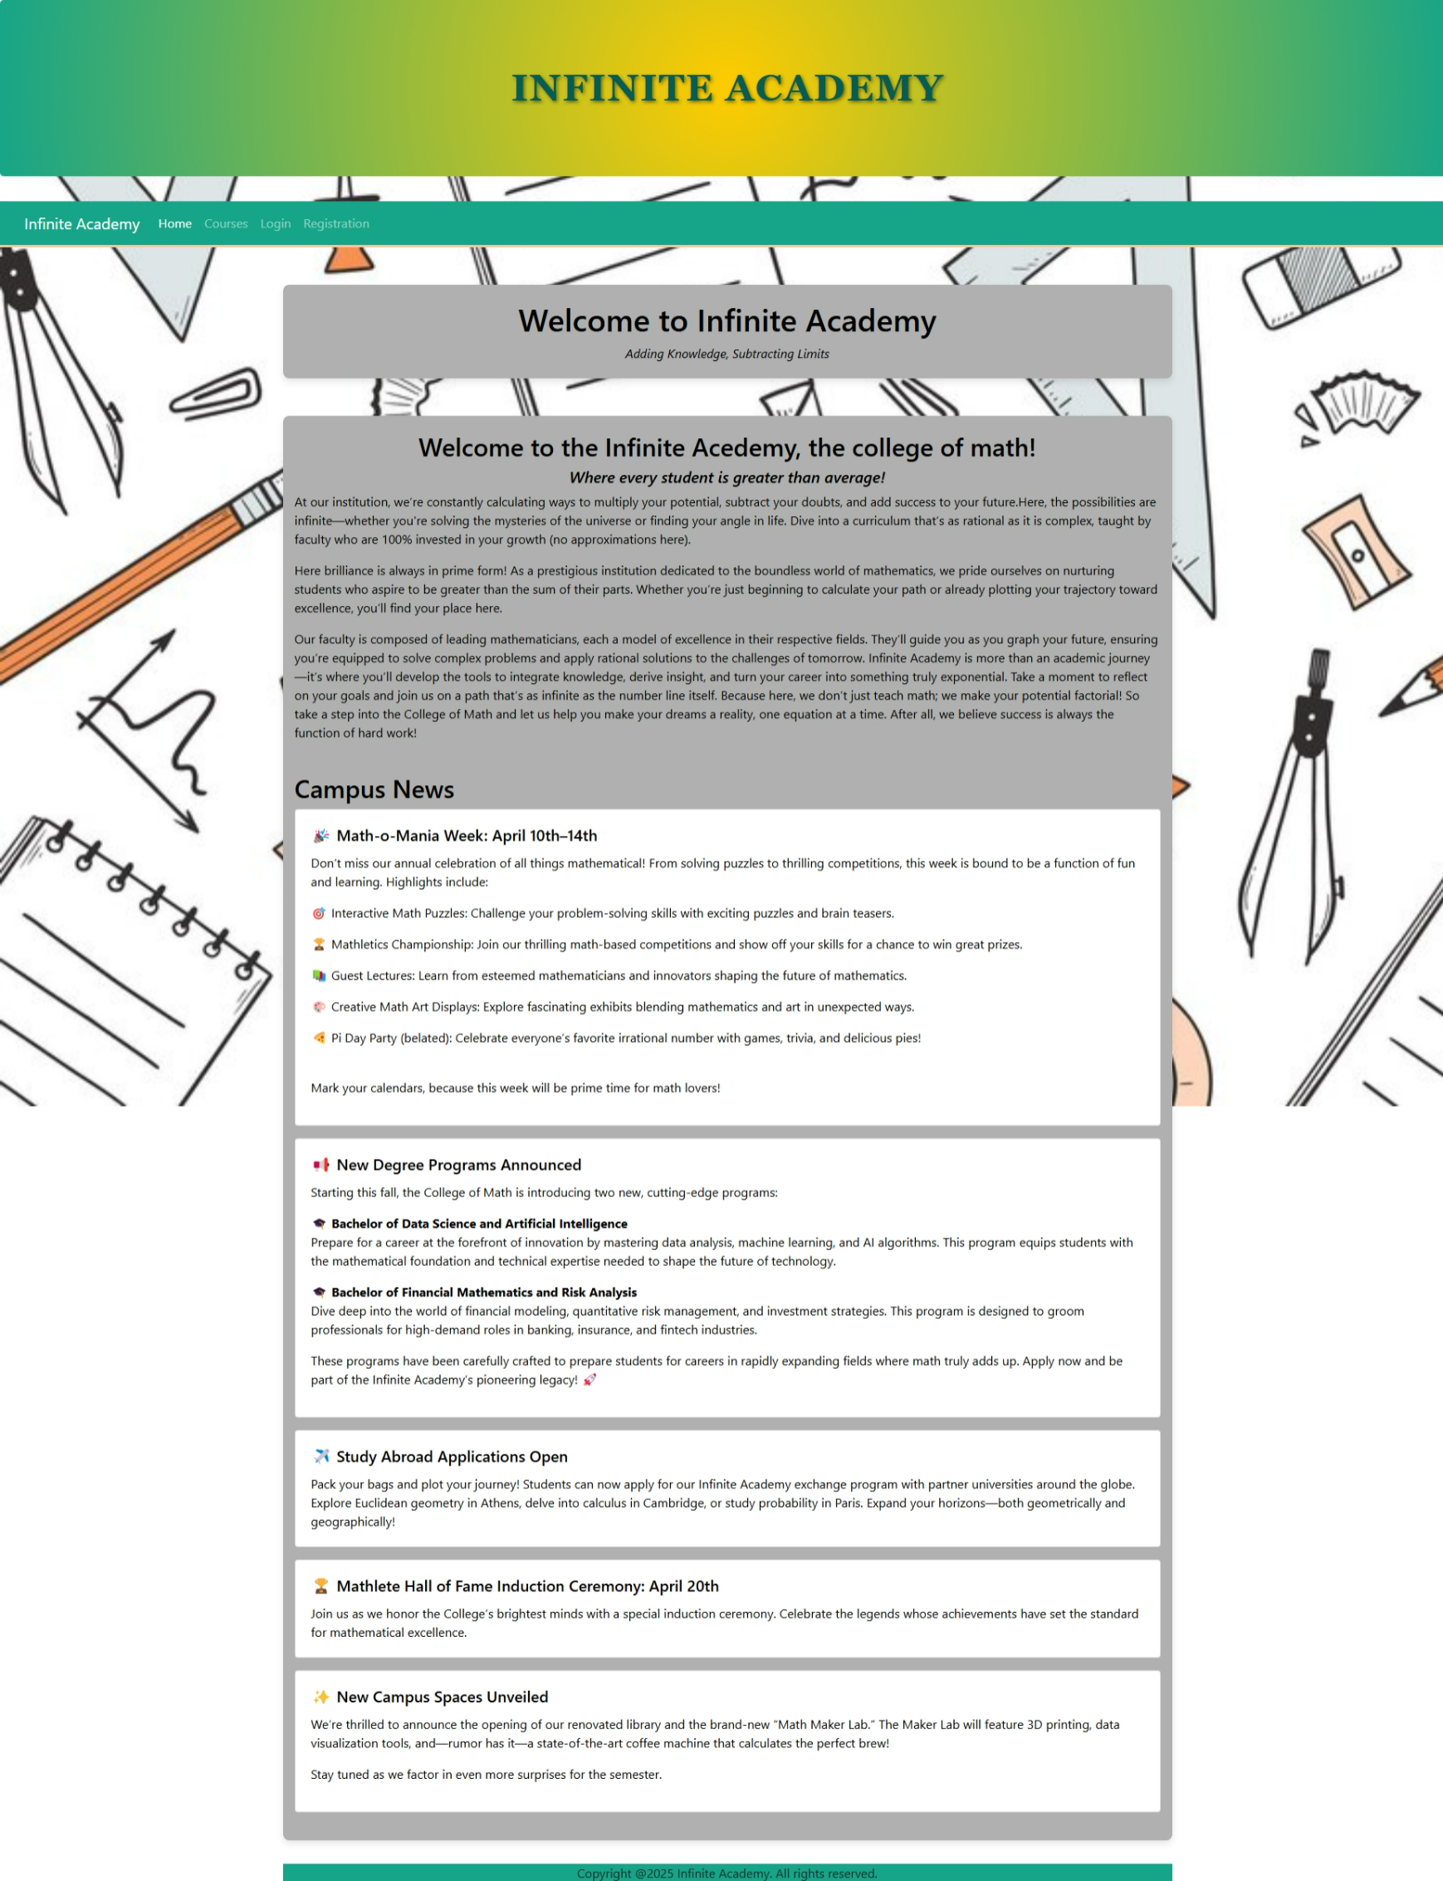

The source code for index.php is shown in Figures 2 and 3. The file begins with error handling to display error notices if any issues arise, aiding debugging. A typical webpage is divided into three main sections: head, body, and footer (W3Schools, n.d.). The <head> element acts as a container for metadata and is usually placed between the root element (HTML) and the body element (Connolly & Hoar, 2022). Common elements within the head tag include <title>, <style>, <link>, <meta>, <script>, and global attributes (W3Schools, n.d.). The <meta> tag defines metadata, providing information about the data on the page. The <title> tag specifies the text displayed on the browser tab. The <link> tag connects the page to external files, such as stylesheets, which can include resources from the Bootstrap library. Finally, the <script> tag defines client-side scripts, such as those Bootstrap uses.

The body of the source code contains the main content of the page. It also calls the master.php and footer.php files to include reusable components, such as the navigation bar and footer, ensuring consistency and simplifying the webpage’s structure. The landing page functions as a welcome page for Infinity Academy School, introducing the school and presenting current news. It uses headings and containers to organize and display information effectively. HTML provides six hierarchical heading levels, from <h1> to <h6>, with <h1> being the most important and each subsequent level decreasing in significance (W3Schools, n.d.). Browsers use these headings to define the document's outline, which can be further customized through CSS (Connolly & Hoar, 2022). The landing page format is based on a previous project, allowing the developer to refactor the code and introduce cascading style sheets, which were not used in the previous project.

**Figure 2**

*Index.php Source Code*

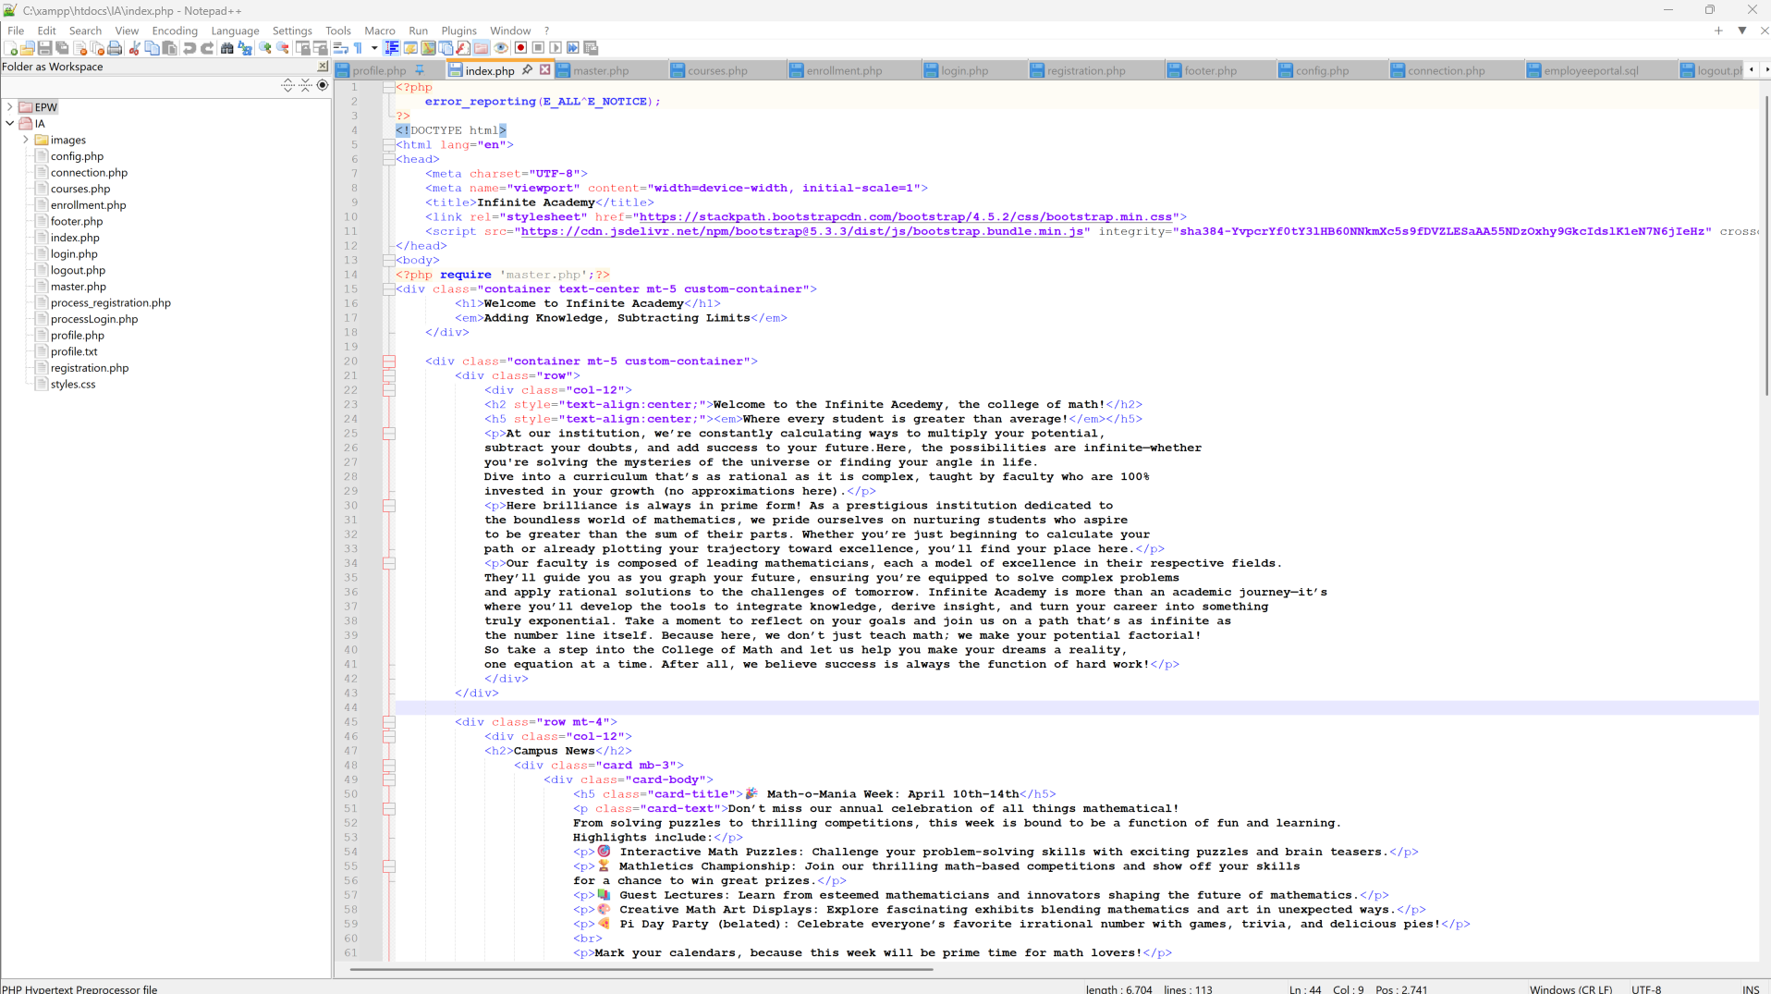

**Figure 3**

*Index.php Source Code Continued*

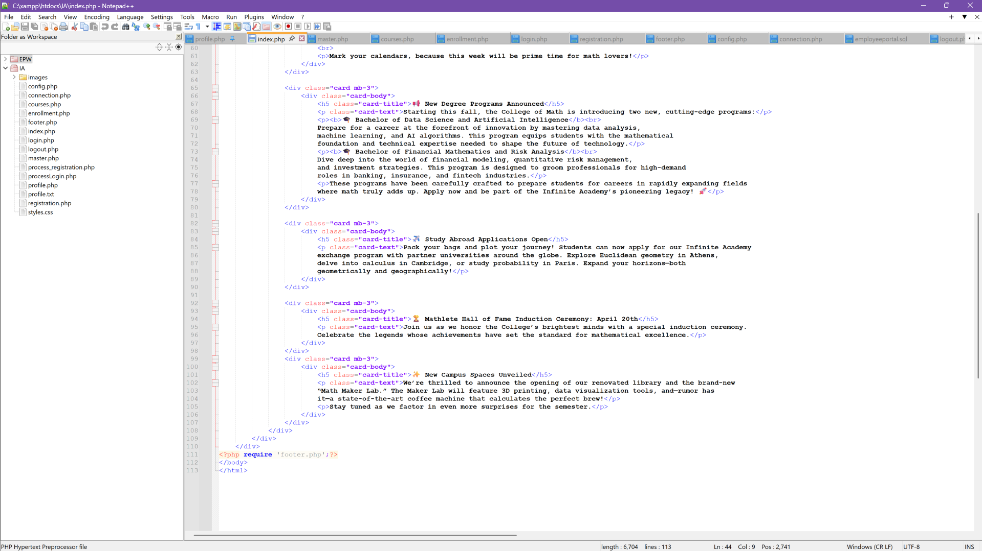

The master.php file, displayed in Figure 4, provides the collapsible navigation bar included on every page. The Home and Course buttons remain static and are accessible to both logged-in and logged-out users. PHP is utilized to define the if/else logic for session users, enabling the navigation bar to dynamically update after a user successfully logs in. This adjustment grants access to pages that require authorization, ensuring only authorized users can view restricted content. Users who are logged out can access the Home, Courses, Registration, and Login pages. It is important to note that the <head> section of the master.php file includes the line <link rel="stylesheet" href="styles.css">, which links the CSS file. Since the master.php file is used across all pages to display the navigation bar, linking the stylesheet ensures consistent formatting throughout the entire site.

**Figure 4**

*Master.php Source Code*

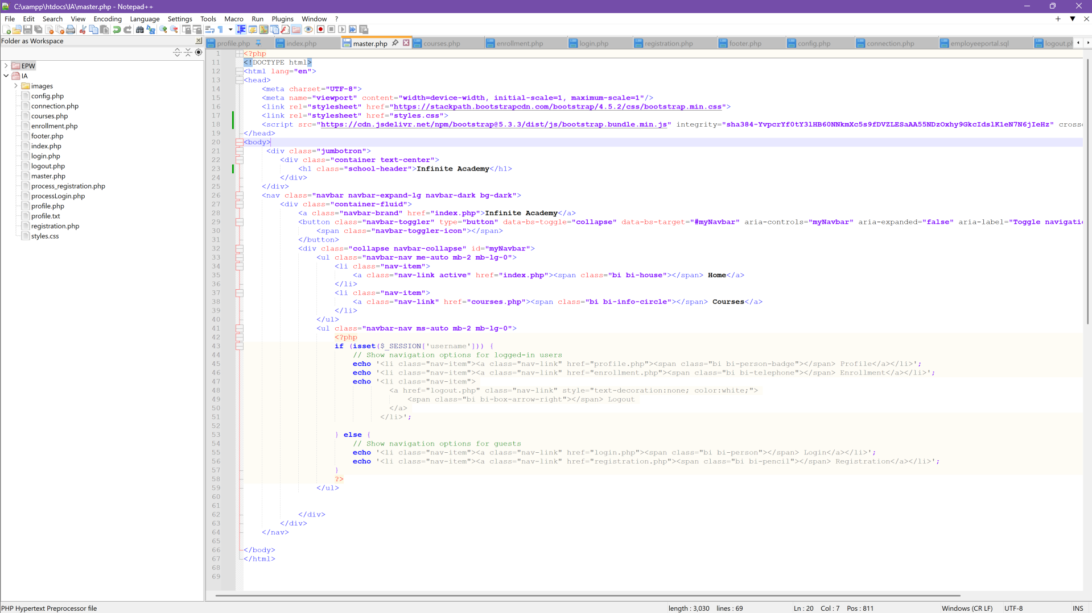

Figures 5 and 6 are the CSS file used to format the webpage. The W3Schools [CSS Tutorial](https://www.w3schools.com/Css/) was used as a reference to create the appropriate formatting for the site (W3Schools, n.d.). Initially, the background image did not cover the entire webpage. As the page content expanded, the bottom portion of the page lacked background coverage. To address this issue, the background-attachment: fixed property was implemented, ensuring the background remains stationary while the user scrolls through the content. There were also challenges with the image displaying correctly when the browser window size was adjusted. To resolve this, a @media (max-width: 768px) media query was used to define the background size, font size, and container padding, providing a responsive design that adapts to various devices. Custom container and form classes were implemented using CSS to add a solid background behind the text, enhancing readability and improving the page's design. These classes define padding, margins, and background color to ensure the text remains visually distinct from the decorative background. Additionally, buttons were styled using external CSS, aligning their colors with the site's overall color scheme for uniformity. This approach maintains consistency and strengthens the visual identity of the webpage.

**Figure 5**

*Style.css Source Code*

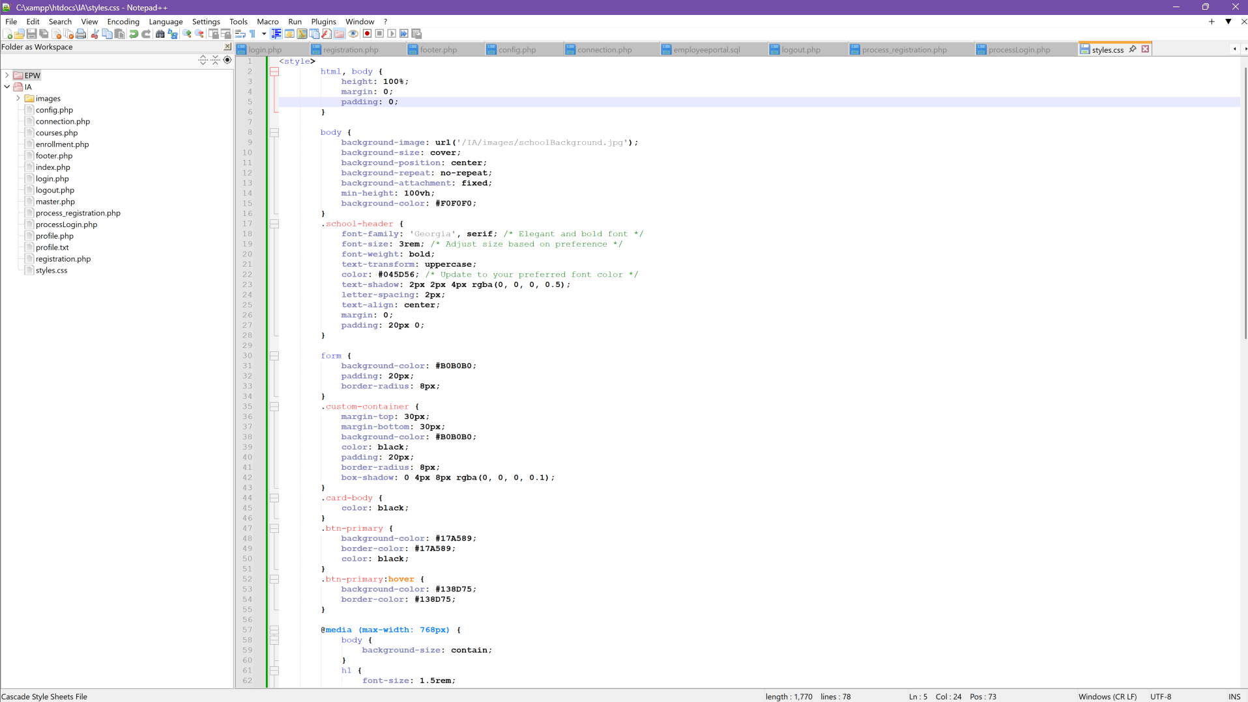

**Figure 6**

*Style.css Source Code Continued*

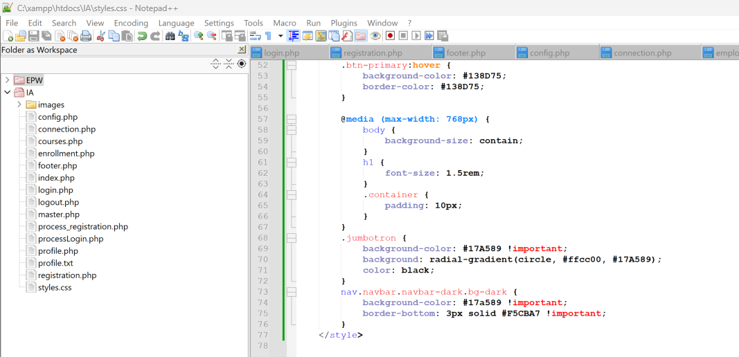

The footer.php file, shown in Figure 7, was designed to enhance the website's aesthetic appeal and provide a copyright notice. To create a cohesive look across the pages, the inline style style="background-color: #17A589 was applied, ensuring the footer's cyan background matched the header within the container. The header utilized the Jumbotron class to appear prominently at the top of the page. This class was customized in the CSS file to include a gradient effect blending cyan and yellow. However, applying the Jumbotron class to the footer caused it to appear excessively large and awkward. To address this issue, a custom style for the footer was defined directly within the body of the footer.php file, ensuring the footer maintained an appropriate size and appearance while complementing the rest of the design.

**Figure 7**

*Footer.php Source Code*

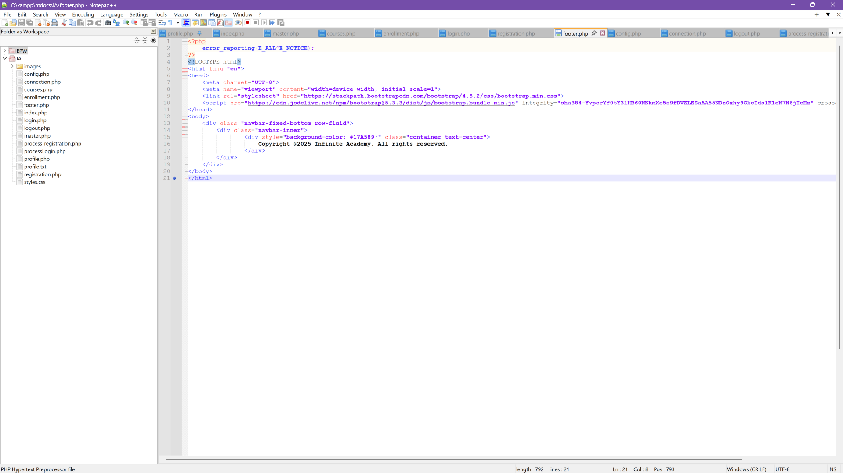

To create the registration page, login page, process files, and database class, [Creating a Registration and Login System](https://www.geeksforgeeks.org/creating-a-registration-and-login-system-with-php-and-mysql/) and [Fundamentals of Web Development](https://uagc.instructure.com/courses/139145/modules/items/7107299) were used as references (Connolly & Hoar, 2022; Myar, 2024). The registration page in Figure 8 and its source code in Figure 9 utilize a form to capture user input. The <form> element is used to create a form for user input, and the ‘type’ of input fields within the form is determined by the attribute in the <input> elements (W3Schools, n.d.). The method was set to POST to securely transmit user credentials through the HTTP POST request body (Connolly & Hoar, 2022). The <label> element was used to provide captions, such as "Email," associated with the form inputs, enhancing accessibility and clarity. The input type for the email field was defined as ‘Email,’ which enables automatic validation to ensure the input is formatted as a valid email address (MDN Web Docs, n.d.). The ‘required’ attribute was applied to guarantee that the user provides input before the form can be submitted. This process was repeated for all essential fields to collect the necessary user information. Although additional data could have been collected, only a limited and necessary amount was required. If the academy wishes to gather more information in the future, the form can be extended to include additional fields. However, adhering to good security practices, only essential information should be collected to minimize the risk of potential breaches and reduce the threat surface. This ensures that data protection and user privacy remain a priority (Wills, 2022).

**Figure 8**

*Registration Page*



**Figure 9**

*Registration Page Source Code*

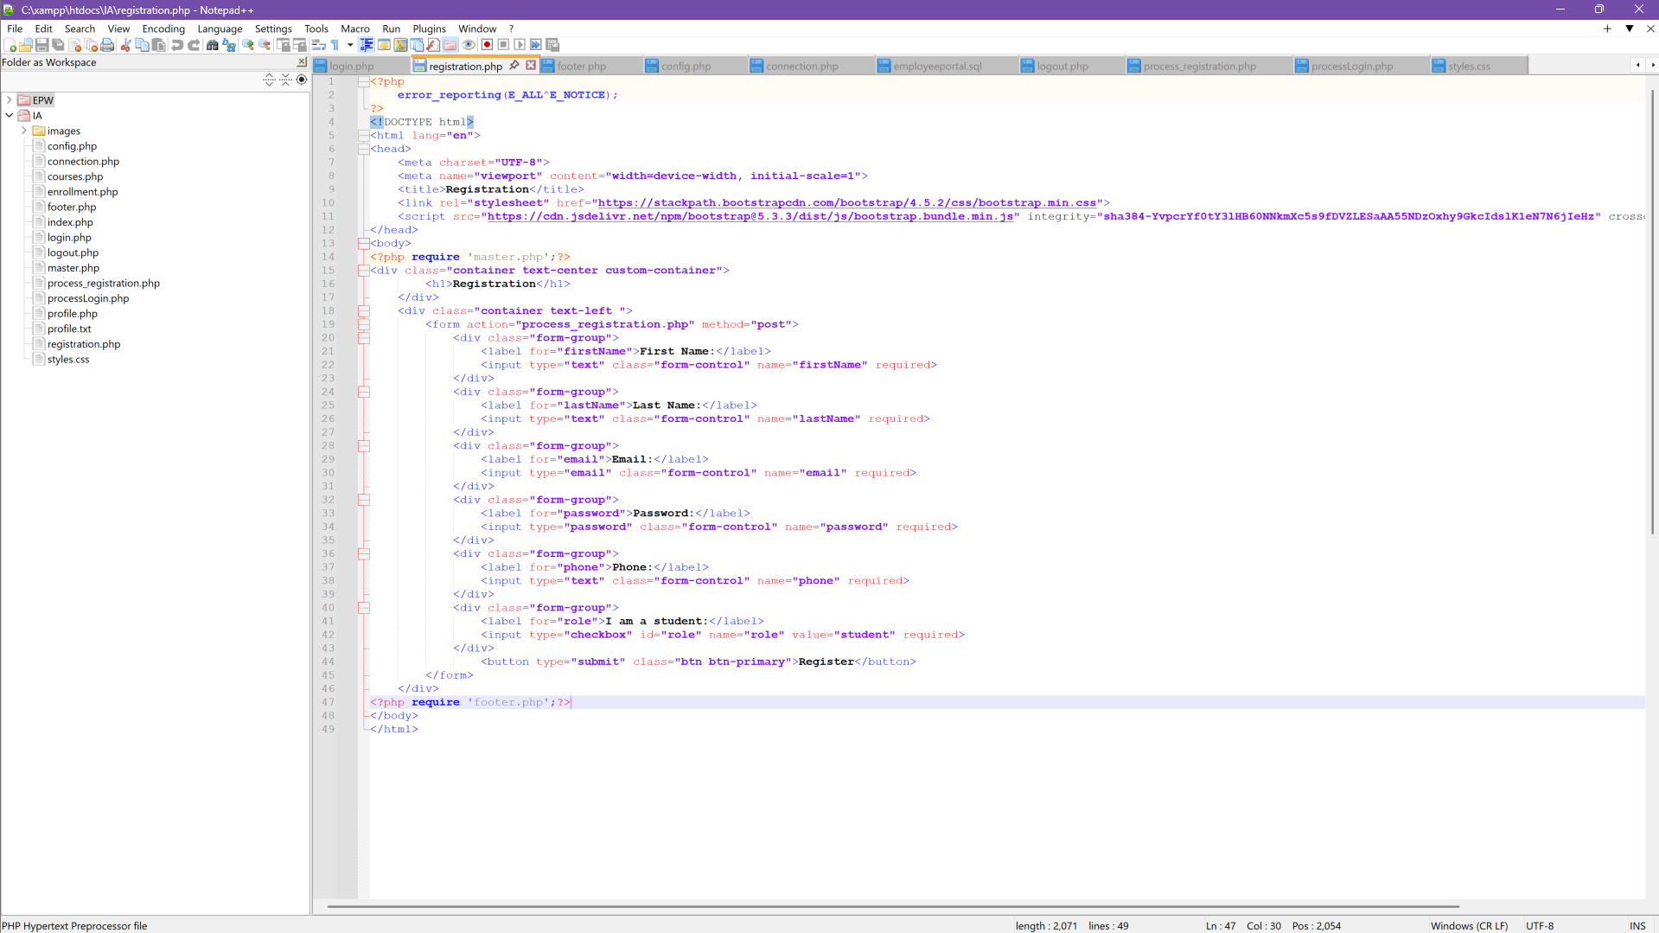

Next, the educationalPortal database, shown in Figure 10, was created in phpMyAdmin to store user information. The database includes four tables: courses, enrollment, user, and waitlist. The user table in Figure 11 contains six fields: userID, email, password, firstName, lastName, phone, and role. The database implements role-based access control (RBAC), which defines different user permissions based on their roles. To support RBAC, the role field was defined with the enum data type, allowing for customization of acceptable input values. The student registration form includes a checkbox labeled "I am a student," enabling users to indicate their role during registration. In contrast, faculty roles are managed exclusively by the database administrator to enhance security and reduce potential vulnerabilities (Wills, 2024).

Data definition language (DDL) commands were used to define the database structure. DDL is a foundational category of SQL statements that specifies the framework of a database and its objects (CSULB, n.d.). Data manipulation language (DML) statements were utilized to manipulate data within the database. DML encompasses querying and modifying data commands, such as INSERT, UPDATE, and DELETE (Coronel & Morris, 2019). These commands play a vital role in managing the database’s contents. The primary key of each table is denoted by a key icon in phpMyAdmin, ensuring uniqueness within the database.

**Figure 10**

*educationPortal Database in phpMyAdmin*

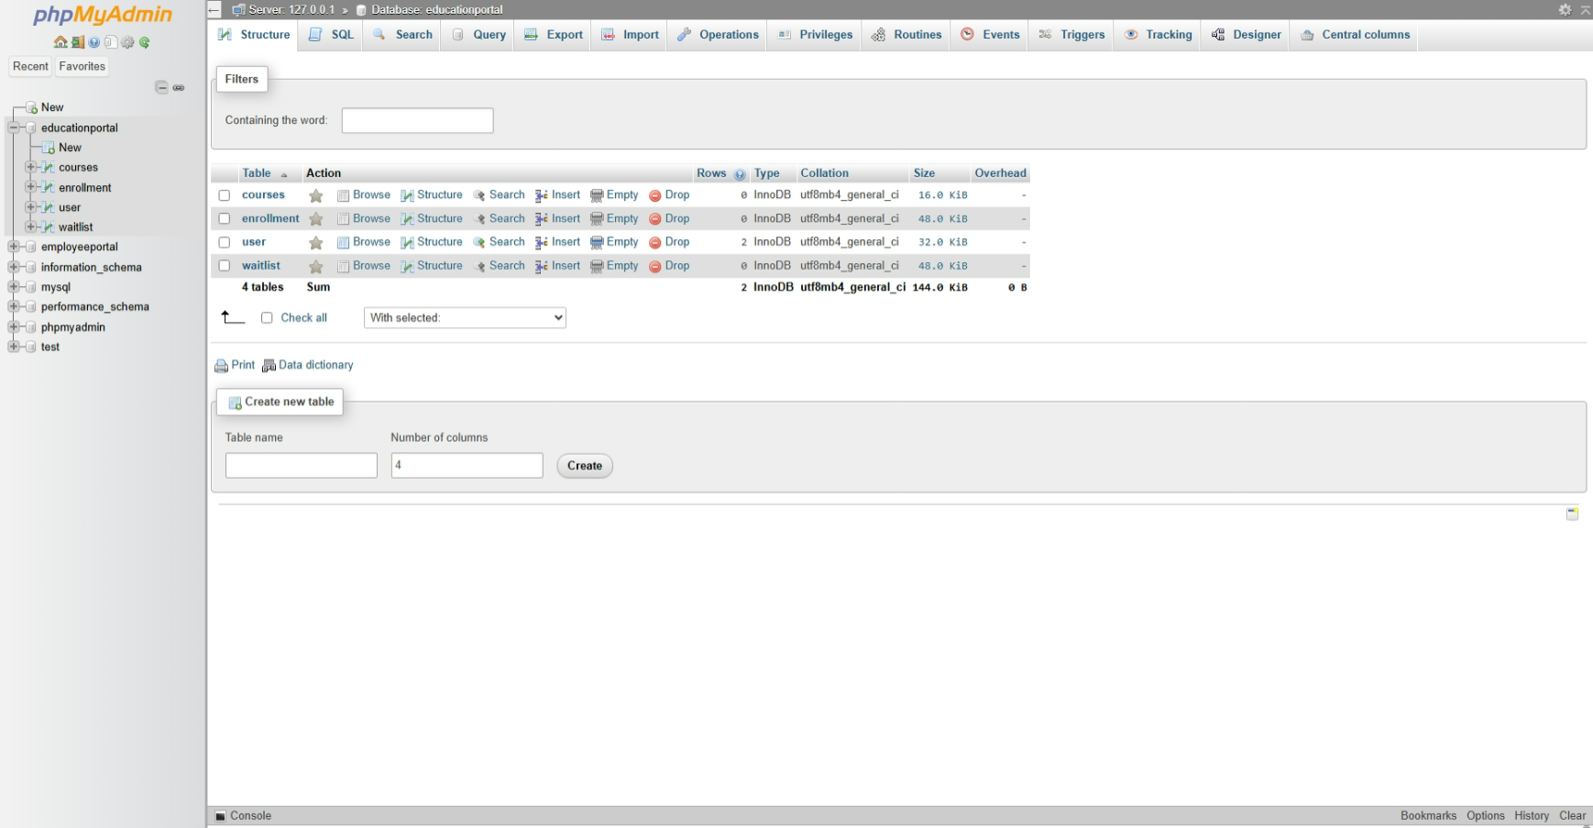

**Figure 11**

*User Table in Database with New Record Successfully Added from Webpage*

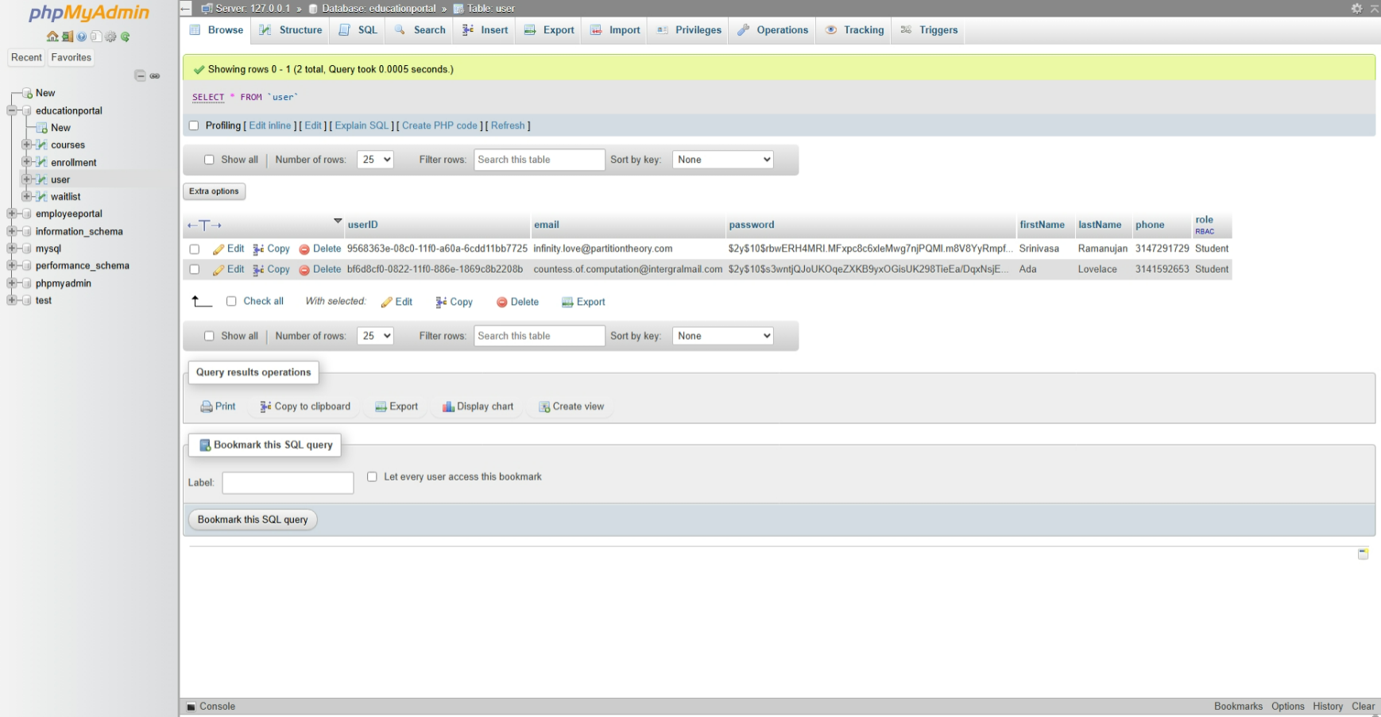

To create the database connection in Figures 12 and 13, the basic database connection algorithm was applied: connect to the database, handle connection errors, execute the SQL query, process the results, free resources, and close the connection (Connolly & Hoar, 2022). The PDO (PHP Data Objects) approach was used for the script to ensure secure and flexible database interactions. Connection details were defined as constants in the config.php file, separating sensitive information for better manageability and security. It is important to note that the DBUSER defined in the config.php file was granted all privileges on the educationPortal database to allow access to the database, as shown in Figure 14. The connection.php file used require_once to include the config.php file and access the connection parameters. A Database class was then defined, featuring a private $pdo variable to encapsulate database connection details securely. The constructor method (__construct) was implemented to establish the database connection using the parameters from the config.php file, with error handling enabled through ERRMODE_EXCEPTION for debugging purposes. Additionally, the getConnection method was created to provide access to the private PDO connection established in the constructor method.

Next, the executeSelectQuery function was implemented with two parameters, $con and $sql, to retrieve data from the database and return it as an associative array. The $con parameter represents the active database connection object, established using the PDO extension, enabling communication with the MySQL database. The $sql parameter contains the SQL query string to be executed. The line $statement = $con->query($sql) executes the SQL query stored in $sql using the database connection $con. The function then utilizes the fetchAll method to fetch all rows from the result set and return them as an associative array. Error handling was implemented using a catch block, where getMessage displays any errors that occur during execution. The executeQuery function was designed to modify data in the database, such as performing SQL operations like INSERT, UPDATE, or DELETE. It accepts the database connection object and the SQL statement as arguments and executes the provided statement to update the data. The line $con->exec($sql) executes the SQL statement to perform the modification. Error handling was once again implemented using a catch block. Finally, the closeConnection function was created to free resources and close the database connection, ensuring efficient resource management.

**Figure 12**

*Config.php Source Code*

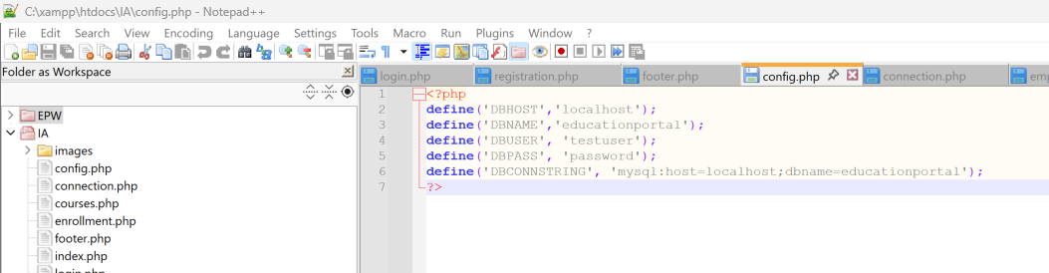

**Figure 13**

*Connection.php Source Code*

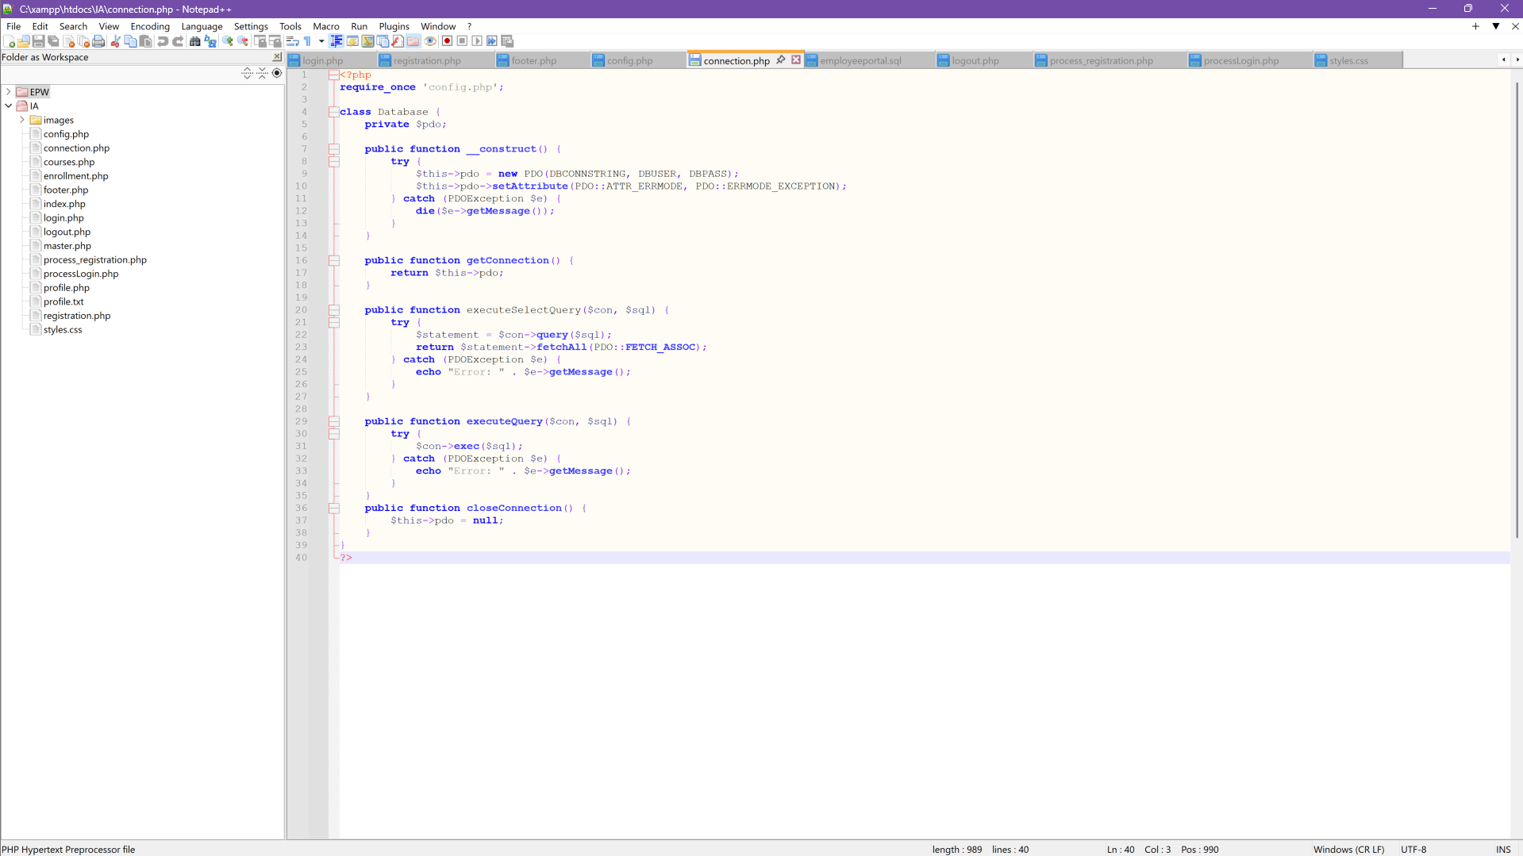

**Figure 14**

*Testuser Granted Privileges*

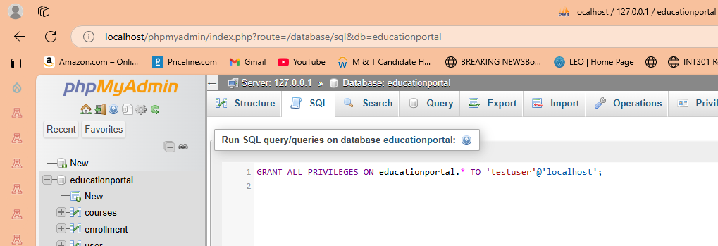

After the form is created to collect user registration data, a corresponding database table is designed to store this information. The config.php and connection.php files are implemented to establish the website's connection to the educational portal database. The process_registration.php file is then developed for backend operations, facilitating the storage of user data in the database. The file accesses the config.php and connection.php files using require_once for database configuration and connection setup. A database object, $db, is created, and its associated method, getConnection, is used to maintain the session. User input is retrieved from the $_POST array, where it is stored after the form submission. Each field is assigned to a new variable. The password is secured using the password_hash method with the PASSWORD_DEFAULT parameter to ensure the most up-to-date hashing algorithm is applied.

A universally unique identifier (UUID) statement is executed to generate the userID. SSR requirements specify that each user must have a unique ID. While auto-incrementing could have been used in the database, it would produce consecutive numbers, increasing security vulnerabilities. Using the UUID method ensures a universally unique ID, eliminating the risk of collisions if the system is later scaled or integrated with other systems. An SQL INSERT statement is then used to add the new record to the database. Finally, the parameters are bound to the SQL statement, and the file uses an if/else statement to either confirm successful registration or display an error message for handling exceptions. Figure 16 shows that the registration was successful.

**Figure 15**

*Process_registration.php Source Code*

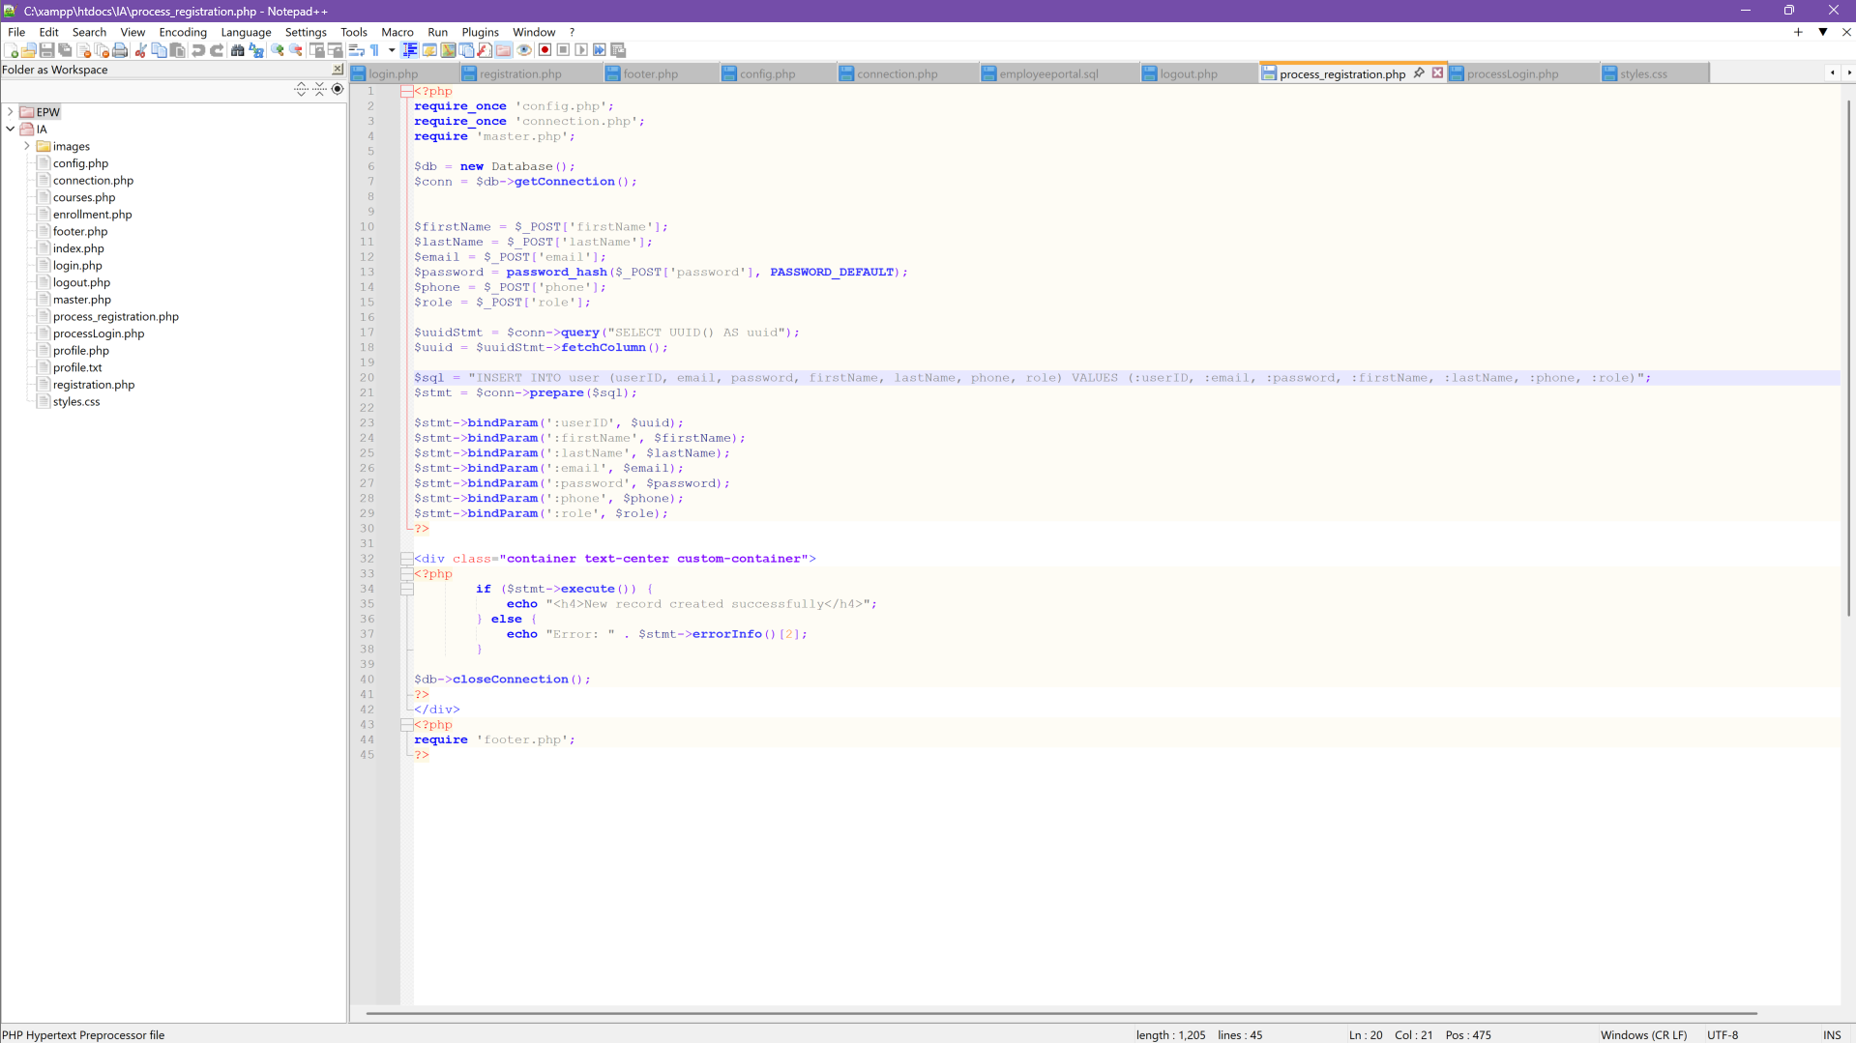

**Figure 16**

*New Record Created Successfully Message Handling*



The login page is shown in Figure 17. The steps involved in creating the login page include designing the HTML structure for the layout, as illustrated in Figure 18, and developing the PHP script to handle form submission, as shown in Figure 19. Additionally, the login page features a personalized welcome header, and the script ensures that navigation links dynamically update based on the user's session status. The process for collecting user input is similar to that of the registration page, utilizing a form with the ‘POST’ method to gather the user's email and password.

While the majority of the content in these files was derived from code reuse, mimicking the design of a previous project, additional security measures were implemented, including password hashing. The password is hashed immediately after the user input is processed from the registration form. The hashed password is stored in the database and is retrieved later for comparison with the hashed version of the user login input. To facilitate this comparison, the processLogin.php file uses an if statement to validate and authorize the user's credentials. The email and password are retrieved from the form array and stored as new variables. A connection to the database is established, and a SELECT query is executed to fetch user information matching the provided email. The user data is stored in an array for comparison. An if statement is then used to compare the hashed password stored in the database with the user-provided password using the password_verify function. This function securely verifies that the input matches the stored hash without decrypting the password. If the email and password are verified, an additional if statement is used to confirm that the user role is assigned and the user has the necessary permissions to access restricted areas of the site. Once verified, a SESSION is created, and the user is redirected to their profile page. The user data is then stored in the SESSION array. Else statements handle unauthorized access attempts or invalid credential submissions. Figure 20 shows a successful login of an authorized user that was redirected to their profile page. The top left corner displays an in-session welcome message with the user’s email.

**Figure 17**

*Login Page*



**Figure 18**

*Login Page Source Code*

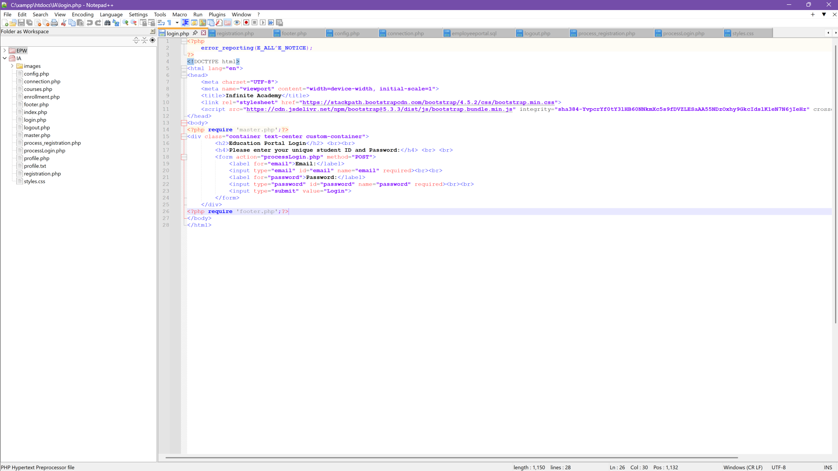

**Figure 19**

*processLogin.php Source Code*

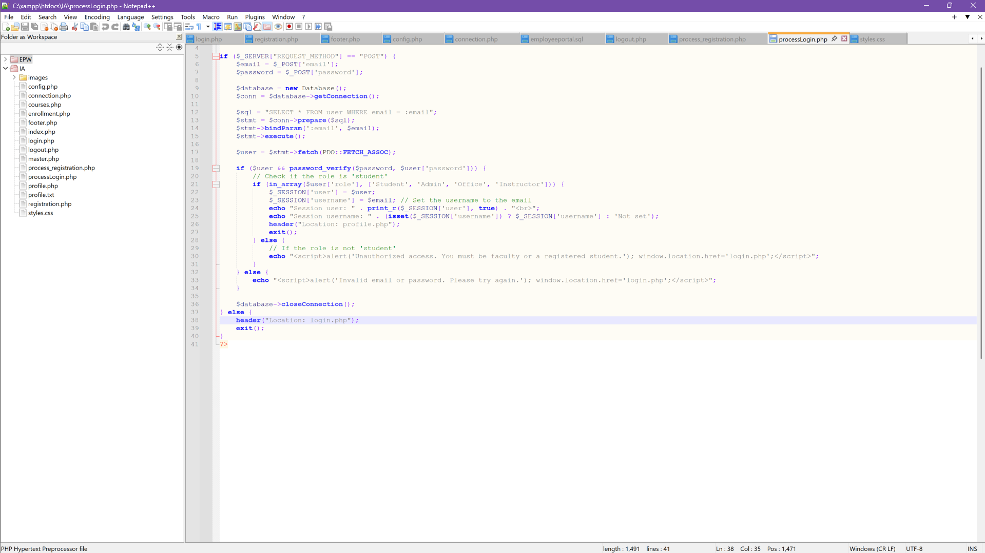

**Figure 20**

*Successful Login: Redirected to Profile with Active Session*



Figure 21 shows the logout.php file. The provided PHP code manages user session termination and redirects the user to the login page. It begins by starting the session with session_start(), then clears all session data by assigning an empty array to $_SESSION. Next, it destroys the active session using session_destroy(). Afterward, the header() function redirects the user to login.php, ensuring they are taken to the login page. Finally, the script execution is terminated with exit() to prevent further code from running.

**Figure 21**

*Logout.php Source Code*

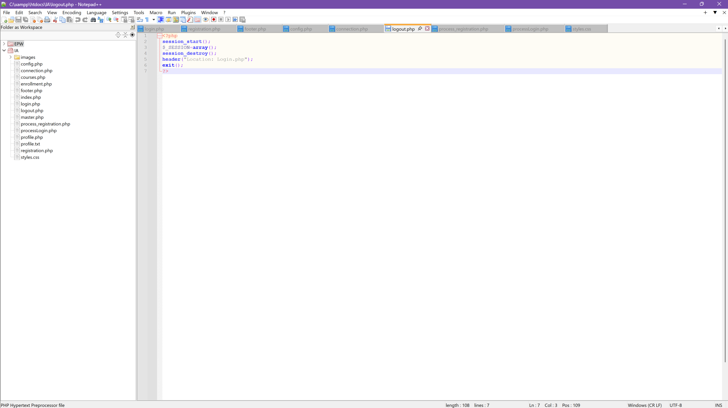

In conclusion, this paper demonstrates the comprehensive process of creating a dynamic website using XAMPP as the development environment. By leveraging principles of code reusability and secure practices, the project successfully developed key pages, including the landing, login, and registration pages, while implementing robust MySQL database functionalities. Each step, from designing the front-end layout to establishing secure database connections and managing user sessions, showcases the meticulous effort involved in constructing a functional and secure web application. The implementation of advanced concepts, such as role-based access control and password hashing, further reinforces the emphasis on data protection and user privacy. This project highlights the integration of foundational web development principles and secure practices, serving as a practical guide for constructing dynamic websites that balance functionality, user experience, and data security.

**References**

California State University, Long Beach. (n.d.). *DDL & DML Database Design.* CSULB.

[Database Design - DDL & DML (csulb.edu)](https://web.csulb.edu/colleges/coe/cecs/dbdesign/dbdesign.php?page=sql/ddldml.php)

Connolly, R., & Hoar, R. (2022). [*Fundamentals of Web Development*](https://uagc.instructure.com/courses/139145/modules/items/7107299) (3rd Ed.). Pearson.

Coronel, C., & Morris, S. (2019). [*Database Systems: Design, Implementation, and Management*](https://uagc.instructure.com/courses/130144/modules/items/6620787)

(13th Ed.). Retrieved from <https://www.vitalsource.com>

Myar. (2024, August 12). *Creating a Registration and Login System with PHP and MySQL.*

Geeks for Geeks.

[Creating a Registration and Login System with PHP and MySQL - GeeksforGeeks](https://www.geeksforgeeks.org/creating-a-registration-and-login-system-with-php-and-mysql/)

PHP Manual. (n.d.). *PDOStatement::bindParm.* PHP.Net.

[PHP: PDOStatement::bindParam - Manual](https://www.php.net/manual/en/pdostatement.bindparam.php)

PHP Manual. (n.d.). *PDOStatement::execute.* PHP.Net. [PHP: PDOStatement::execute - Manual](https://www.php.net/manual/en/pdostatement.execute.php)

PHP Manual. (n.d.). *session_start.* PHP.Net. [PHP: session_start - Manual](https://www.php.net/manual/en/function.session-start.php)

Tsui, F., Karam, O., & Bernal, B. (2018). [Essentials of Software Engineering](https://uagc.instructure.com/courses/143469/modules/items/7317752) (4th ed.). Jones &

Bartlett Learning.

W3Schools. (n.d.). *CSS Tutorial*. W3Schools [CSS Tutorial](https://www.w3schools.com/Css/)

W3Schools. (n.d.). *HTML Forms.* W3Schools. [HTML Forms](https://www.w3schools.com/html/html_forms.asp)

W3Schools. (n.d.). *HTML <form> action Attribute.* W3Schools. [HTML form action Attribute](https://www.w3schools.com/tags/att_form_action.asp)

W3Schools. (n.d.). *HTML <head> Tag.* W3Schools. [HTML head tag](https://www.w3schools.com/tags/tag_head.asp)

W3Schools. (n.d.). *HTML <h1> to <h6> Tags.* W3Schools. [HTML h1 to h6 tag](https://www.w3schools.com/tags/tag_hn.asp)

Wills, M. (2022). [(ISC)2 SSCP Systems Security Certified Practitioner Official Study Guide.](https://search.ebscohost.com/login.aspx?direct=true&AuthType=shib&db=nlebk&AN=3137727&site=eds-live&scope=site&custid=s8856897&ebv=EB&ppid=pp_C1)

(3rd ed.). Wiley Professional Development (P&T).